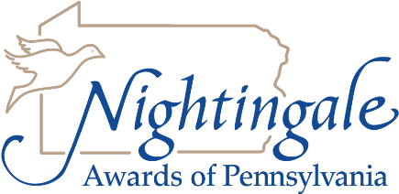
Signature Page
Awards 2019

“By signing below, I agree to be considered for the Nightingale Awards of Pennsylvania (NAP) and to participate in the awards program if chosen. I understand that NAP may contact my present employer and I authorize said employer to release information pertinent to such a request.”

_____________________________________________ ___________________
Candidate Signature Date

“By signing below, I agree that all of the information provided in the Awards Application are true and correct.”

_____________________________________________ ___________________
CNO, Director or CEO Signature Date

_____________________________________________ ___________________
Nominator Signature Date

